|  |
| --- |
| E:\My Documents\Desktop\Logo_FPT_University_doc.jpg |
| **Capstone Project Introduction** |
| **Lynxmotion A-Pod  robot controller** |
|  |
| |  |  | | --- | --- | | **Team 15** | | | **Supervisor** | Mr. Trần Khánh Ninh | | **Group Members** | Phan Anh Dũng Cường () – Leader  Nguyễn Minh Quân (60344)  Cao Đình Nguyên Khoa() | | **Ext Supervisor** |  | | **Capstone Project code** | **APOD** | |

**Record of Changes**

|  |  |  |  |  |
| --- | --- | --- | --- | --- |
| **Date** | **Change Item** | **Description** | **By** | **Version** |
| 9/9/2013 | All | Create the document | QuanNM | 0.1 |
|  |  |  |  |  |
|  |  |  |  |  |
|  |  |  |  |  |
|  |  |  |  |  |
|  |  |  |  |  |

Table of Contents

I. Introduction 2

1. Project Information 2

2. Description 2

3. Purpose 2

4. The People 3

5. Why we need A-Pod Robot 3

## I. Introduction

## Project Information

* Project name: **Lynxmotion A-Pod  robot controller**
* Project code: **APOD**
* Product type: **Embedded robot controller**
* Timeline: **from September 2013 to December 2013**

## Description

A-Pod Robot is a automatic/ manual controlling system. Assembly with 6 leg (3 DOF), A mandible and Tail. It has total 25 servos to serve moving, rotating, gripping. There are three basic board for controlling (A SSC32 servos controller, STM32F4 Discovery using ARM, BOT BOARD II using BASIC ATOM PRO 28)\*

P/s: \* each of board will be define and description later.

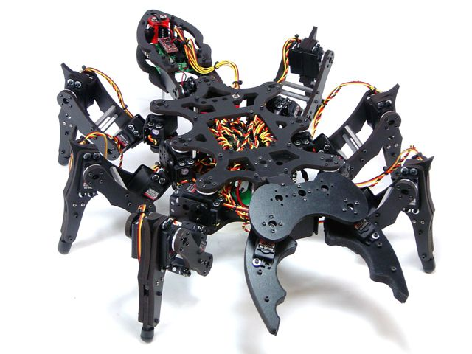

## Purpose

This project focus on programming on microprocessor unit (MCU) to developing, control the A-Pod robot. The BASIC is let him move forward, backward, right, left. Thus, we concern on control over Bluetooth. Through Camera put on robot control it/ or automatic function, connect with Sensor to discover obstructions.

Abstracts purpose: Design the controller board motor servo using microcontroller to control Lynxmotion A-Pod  robot  with available mechanical. Implement the hardware and software on PC to control Lynxmotion. The system requires Microcontroller ARM LPC,AT91SAM,PIC,AVR; Finding critical points and find best way algorithms

## The People

Supervisor:

|  |  |  |  |  |
| --- | --- | --- | --- | --- |
|  | **Full name** | **Phone** | **E-Mail** | **Title** |
| Supervisor 1 | Trần Khánh Ninh | 0909503464 | ninhtk@fpt.edu.vn | Mr |

Team members:

|  |  |  |  |  |  |
| --- | --- | --- | --- | --- | --- |
|  | **Full name** | **Student code** | **Phone** | **E-mail** | **Role in Group** |
| Student 1 | Phan Anh Dũng Cường | SE60774 | 0972708318 | Cuongpadse60774@fpt.edu.vn | Leader |
| Student 2 | Nguyễn Minh Quân | 60344 | 0915699635 | Quannm60344@fpt.edu.vn | Member |
| Student 3 | Cao Đình Nguyên Khoa |  |  |  | Member |

## Why we need A-Pod Robot

The main purpose of A-Pod Robot is to be used at home with variable simple tasks. The Project ‘s scope is to control A-Pod from a distance via a HCI program on PC (or mobile devices). A-Pod can perform task without the present of human and report back working information when needed.

## Product

* HCI program on PC.
* Embedded Program to control A-Pod movement and communication with HCI program on PC.

## Task

|  |  |  |  |  |
| --- | --- | --- | --- | --- |
| **Date** | **CuongPAD** | **QuanNM** | **KhoaCDN** | **Notes** |
| 9/9/2013 | A-Pod movement module (embedded software and .net library) | Communication module (Bluetooth & wireless camera) | Obstructions sensor module. |  |
|  |  |  |  |  |
|  |  |  |  |  |
|  |  |  |  |  |
|  |  |  |  |  |